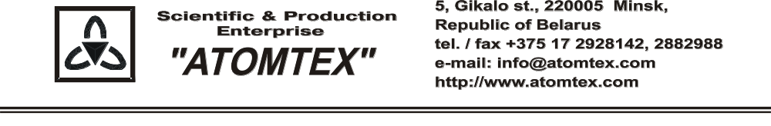

CALIBRATION CERTIFICATE

Date of calibration 17.12.2018

Type Radiation monitor AT6130

S/N 21732

Measurement limits:
from 0.1 μSv/h to 10 mSv/h,
from β: 0,5 - 500 Bq/cm²

Measurement error ±20 %

Operating conditions:

Air temperature +19°C
Atmospheric pressure 96,8 kPa
Relative humidity 75%

The instrument is calibrated on the standard dosimetry facility AT-130, N 015, error ±4% (the Certificate of Compliance N 210/1427-2018 on 23.10.2018 issued by FGUP "D.I.Mendeleyev VNIIM", St. Petersburg, Russia); AT-110, N 013, error ±5% (the Certificate of Compliance N 210/1426-2018 on 22.10.2018 issued by FGUP "D.I.Mendeleyev VNIIM", St. Petersburg, Russia) and on the beta radiation source of Sr-90+Y-90, error of ± 6 % (the certificate N 48-482377/1 issued by BelGIM, Minsk, the Republic of Belarus).

Calibration data

Gamma radiation
Conventionally true value (CTV) of dose rate, 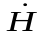*o_{i}(10) | Calibration data
0.70 µSv/h | 0.70 µSv/h
7.0 µSv/h | 7.1 µSv/h
70 µSv/h | 70 µSv/h
0.70 mSv/h | 0.67 mSv/h
7.0 mSv/h | 7.1 mSv/h

Beta radiation
Surfase activity, ϕ _{Ri}, Bq/cm² | Calibration data
4,45 | 4,42
10,4 | 10,3
266 | 248

Calibrated by: S. Kulchynski _____________
(signature)

Technical control: N. Kurbatova _____________
(signature)

